Technical requirements for
casinos when connecting gaming machines (AWP) to the Danish Gambling Authority’s central monitoring system

Version 1.0

Contents
Change log 2
1.0 Introduction 3
2.0 Introduction to the overall system complex 4
3.0 General requirements 5
4.0 SAFE – The Licence Holder’s data store 5
4.1 Technical requirements for SAFE 6
4.2 Use case and process for retrieving data from SAFE 6
UC 2.1 Retrieve Standard Records from SAFE 7
5.0 Interface to security system – Tamper Token 9
5.1 Technical requirements in relation to Tamper Token 9
6.0 Technical information to be given during the connection process 10

Change log

Version | Description of changes | Date
1.0 | Official version. | 01-09-2012

1.0 Introduction
The purpose of this document is to describe the technical requirements to be met by casinos (hereafter the Licence Holder) when connecting gaming machines (AWP) to the central monitoring system. The requirements are described in relation to the systems that will be used in connection with the Danish Gambling Authority's control of the Licence Holder, i.e. the Licence Holder's data store - SAFE - and the security system Tamper Token.

The individual sections contain descriptions of the requirements to be met by the Licence Holder in relation to data, processes and interfaces when connecting to the central monitoring system.

Next, there is an outline of the requirements in respect of technical information regarding the connection process. The requirements stated as information to be provided in the connection process are not exhaustive at this time. Thus, it should be expected that there will be further requirements to the Licence Holder when connecting to the central monitoring system.

The document will also be updated with information about the elements of the connection process.

The final versions of the documents containing requirements for Licence Holder, including Technical requirements for Licence Holder, Conceptual Model and Standard Records, is expected to be published at the end of August 2012. Details about the connection process are expected to be published mid-September 2012 and the connection process of Licence Holders to the central monitoring system is ecptected to be completed from mid-October 2012 to the end of November 2012. All Licence Holders are expected to be connected to the central monitoring system at the end of November 2012. If a Licence Holder can not be ready to complete the connection process by mid-October, the Danish Gambling Authority must be informed as soon as possible.

2.0 Introduction to the overall system complex
The overall system complex for gambling control is shown in the illustration below.
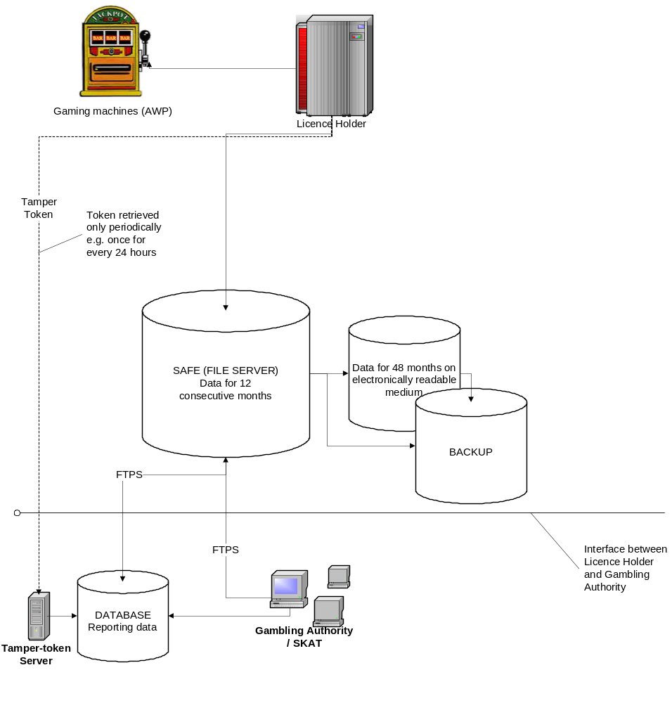
Outline of the components of the overall gambling and control system

The system complex consists of the Licence Holder’s Gaming machines (AWP), Licence Holder's gambling system, the Licence Holder's data store (SAFE) and a security system (Tamper Token).

- SAFE is the Licence Holder's own data store (a file server) where the Licence Holder is required to store data - in accordance with Standard Records - for all gaming machines (AWP) hosted by the Licence Holder. All Licence Holders are required to establish data storage facilities (SAFE). The Danish Gambling Authority must be able to obtain online access to the Licence Holder's data store.
- Tamper Token is a security system which is aimed to ensure that the data saved by the Licence Holder in its SAFE data store remain unchanged while stored by the Licence Holder. Tamper Token will be implemented in the Danish Gambling Authority’s system and handles:

- Creating keys (tokens) used for calculation of identification codes.
- Storing identification codes for later control.
- Ongoing control of compliance with time periods for termination of tokens.
- Verifying that a retrieved series of data has not been changed in relation to the identification code received.

Together, the two systems will help ensure that:
- The gaming machines (AWP) can be connected to the central monitoring system;
- Licence Holders are able to legally provide gambling on gaming machines (AWP) in Denmark and prove that they meet statutory requirements.

3.0 General requirements
As outlined above, the Licence Holder must develop their gaming machines (AWP) so they are capable of using interfaces to the Danish Gambling Authority’s systems. This will allow the Danish Gambling Authority to process data and check that gambling on gaming machines (AWP) takes place in accordance with regulatory requirements. It is a requirement that the Licence Holder uses the specified interfaces to the Danish Gambling Authority’s systems developed by the Authority for this purpose and that the Licence Holder sets up a SAFE to which the Danish Gambling Authority will be given access.

In order to comply with the rules laid out in the new legislation, Licence Holders must follow a number of technical requirements regarding the systems mentioned. In the sections below, these technical requirements will be specified in greater detail. The requirements are grouped according to the system to which they belong.

4.0 SAFE – The Licence Holder’s data store
The Licence Holder must establish a data store (SAFE) for the storage of gambling data. The Licence Holder must transfer and save gambling data in the data store according to Standard Records. The Licence Holder must store gambling data in SAFE for 12 consecutive months and data from a further 48 months must be stored on a digitally readable medium.

Data transfer is done over the internet with FTPS. The License Holder must establish a suitable connection to secure an unproblematic transfer of data.

4.1 Technical requirements for SAFE

- SAFE must be established on a separate server, which is physically detached from the Licence Holder’s gambling system.
- Data stored in SAFE must be separated logically and safely from any other data.
- The Licence Holder must ensure the necessary backup of all data. SAFE and the backup of SAFE must be geographically separated. In addition, the data storage on a digitally readable medium must be geographically separated from the backup of the data thus stored.
- SAFE must meet the same safety requirements as the gambling system. The requirements will be set during the connection process.
- The Licence Holder must ensure that the Danish Gambling Authority will have online access to retrieving gambling data from SAFE. The Licence Holder must establish access to SAFE via a secure connection as defined in the service description.
- The folder structure in SAFE must be built up on the basis of the structure specified by the Danish Gambling Authority. The folder structure may be found at www.spillemyndigheden.dk.
- Data stored in SAFE must have been saved in accordance with the specified Standard Records. The specification of Standard Records may be found at www.spillemyndigheden.dk.
- Data stored in SAFE must be zipped in accordance with the technical requirements. The instruction can be found at www.spillemyndigheden.dk.
- The Licence Holders must document that their respective SAFE systems comply with the requirements defined.
- SAFE must be available 24 / 7 365 days and there should be a guaranteed uptime of at least 98.5 %.
- Licence Holders are responsible for the operation of their own SAFE systems.
- For the Danish Gambling Authority to access SAFE using FTPS, the Licence Holder must place a certificate on the FTPS connection. The certificate must be issued by one of the following Certificate Authorities: VeriSign, Thawte, Geotrust, GoDaddy, Comodo
- The Danish Gambling Authority will access SAFE from these ip-addresses: 91.230.68.13, 91.230.68.190, 194.239.239.10, 194.239.239.30, 194.239.239.31, 194.239.239.32, 194.239.239.33, 194.239.239.34. The Licence Holder must open SAFE for access from those ip-addresses.
- The Licence Holder must configure SAFE so that the following connection is possible: The Danish Gambling Authority must be able to access SAFE with implicit FTPS (FTP-SSL) in passive mode on port 990 (control). As data ports should be used a port range between 40.000 and 50.000. The Licence Holder may use a smaller port range as long as it is with in the two limits.

4.2 Use case and process for retrieving data from SAFE
The Licence Holder must develop an interface for their SAFE that will allow the Danish Gambling Authority to access the SAFE to retrieve data. The required functionality for this interface is described in the ‘use case’ below. The use case may be used in the development of the interface.

UC 2.1 Retrieve Standard Records from SAFE

Purpose
The Danish Gambling Authority must carry through periodic control of completed games based on Standard Records. The Standard Records are placed in the structure specified by the Danish Gambling Authority.

To retrieve Standard Records the Danish Gambling Authority must be logged on to SAFE. When the transfer of data has been ended, the Danish Gambling Authority must log out of SAFE.

Frequency
As required.
Actors
The Danish Gambling Authority
Starting conditions
The Danish Gambling Authority is a recognised user (user name/password) on SAFE.

Main path
Actor | Solution | Service/Service operations
Step 1: Log on to SAFE
The actor requests access to data in SAFE by opening an FTPS connection. | The solution asks the actor for a user name and password.
Step 2: Access to SAFE provided
The actor gives correct user name and password. | Access to SAFE has been provided.
Step 3: Retrieve Standard Records from SAFE
In the file structure the actor locates the Standard Records necessary for control and decides to download them. | SAFE starts downloading and transmits the requested data.
Step 4: Repeat step 3
The actor repeats step 3 if necessary.
Step 5: Log out of SAFE
The actor chooses to log off from the FTPS connection. | The solution logs out the actor and interrupts the connection.

Concluding conditions
The Danish Gambling Authority has access to SAFE, has received the data transferred and logged off after the ending of the transfer.
Notes

Service description

The process to be used by the Danish Gambling Authority when retrieving data from SAFE is illustrated and described below.

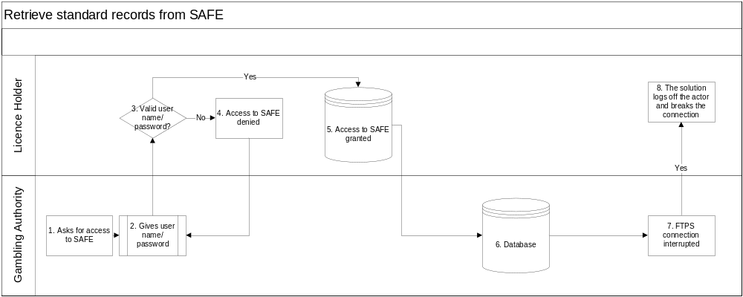
Flow chart – retrieve Standard Records

Process survey |  | Danish Gambling Authority
Process name: | Process owner: | Process stakeholders
UC 2.3 Retrieve Standard Records from SAFE | Danish Gambling Authority | Licence Holders and Danish Gambling Authority
Purpose of the process | The purpose of the process is to ensure that the Danish Gambling Authority can retrieve data from the Licence Holder’s SAFE.  The process is to be used when the Danish Gambling Authority wants to retrieve data from SAFE to be used in its control of online gambling.
Process interfaces | FTPS access
Input (start) | The process starts when the Danish Gambling Authority requests access to SAFE giving its user name and password. SAFE has been set up by the Licence Holder to provide access for the Danish Gambling Authority.
Output (end) | The process ends when the Danish Gambling Authority has obtained the requested data and has logged off SAFE.

Description of process flow (activities)
No. |  | Description
1. | The Danish Gambling Authority requests access to SAFE.
2. | The Danish Gambling Authority ‘fills in’ its user name and password.
3. | The system validates user name and password
4. | If the user name and password are not valid, access to SAFE is denied
5. | If the user name and password are valid, the system grants access to viewing data in SAFE and download may be commenced.
6. | Data are transferred to the Danish Gambling Authority’s database.
7. | The Danish Gambling Authority logs off SAFE FTPS
8. | SAFE logs off the Danish Gambling Authority.

5.0 Interface to security system – Tamper Token
The Danish Gambling Authority implements a security system – Tamper Token. The purpose of the Tamper Token system is to ensure that data, i.e. Standard Records, will remain unchanged while they are stored in SAFE at the Licence Holder’s end.

Tamper Token will handle the following functions:

- Creation of keys (tokens) to be used in the calculation of the MAC (Message Authentication Code)
- Storage of MACs for later control
- Continuous control to check that the period of time for terminating tokens is observed
- Verifying that a retrieved series of Standard Records has not been altered relative to the received MAC

The frequency of the issue of the Tamper Token will be agreed in the course of the connection process. The agreed frequency may be adjusted later based on a specific assessment in relation to the particular Licence Holders.

5.1 Technical requirements in relation to Tamper Token
The License holder must retrieve a token, at the designated frequency (e.g. once every 24 hours). The token must be used when saving data based on Standard Records in SAFE. For that purpose The Danish Gambling Authority will develop a service named “TamperTokenAnvend” which has two operations:

- TamperTokenHent: The operation must be used when the License Holder has to retrieve a token.
- TamperTokenLuk: The operation must be used when the License Holder has to finish a token.

It is a requirement for the Licence Holder that a token is terminated within the defined period of time.
The descriptions of the particular services are published on the Danish Gambling Authority’s website (www.spillemyndigheden.dk).

6.0 Technical information to be given during the connection process
The connection process will involve a number of requirements for technical information, including information such as:

- IP address, username and password of SAFE
- Address of the location of the gambling system and SAFE
- Address of the location of backup systems
- Technical description of the gambling system with an illustration
- Gambling software
- Description of backup systems, including business rules defining how errors etc. will be handled
- Possible certifications of hardware, software and security
- Technical contact person

As stated above, the list should not be considered exhaustive and further requirements to be met by the Licence Holder may therefore be added.

